

RELIABILITY-DRIVEN PRODUCT RECOMMENDATION SYSTEM
A REVIEW-RELIABILITY-WEIGHTED RANKING FRAMEWORK
ON THE AMAZON REVIEWS 2023 ELECTRONICS CORPUS
Developed as part of the course on “Recommender Systems”
at Vellore Institute of Technology, Chennai
PRIYANKA S – 23MIA1032
KAVYA N – 23MIA1125
A PROJECT REPORT SUBMITTED TO
Faculty Name: Dr S Vigneshwari (54147)
Subject Code: CSE4077
Slot: A1+TA1
Semester: Fall 2026-27

1. Abstract
Product recommendations on large e-commerce platforms are usually driven by raw star ratings, yet ratings do not all deserve the same trust: a verified purchase supported by a detailed, community-endorsed account says something materially different from a short unverified complaint. This report presents a reliability-driven product recommendation system, developed for the course CSE4077, that weights every review's contribution to the recommendation models by an explicit and auditable reliability score.
The system is built on a 60,000-review sample of the McAuley-Lab Amazon Reviews 2023 Electronics corpus, covering 41,152 reviewers, 9,846 products and the full one-to-five-star rating range. Five checkable signals - verified purchase status, review depth, reviewer history, community helpful votes and rating calibration - are fused into a 0-100 reliability score and mapped to a recommendation weight between 0.4 and 1.0, so every rating keeps a floor of influence while trustworthy ratings count up to 2.5 times more. Four recommendation models are implemented and compared: a Bayesian popularity baseline, user-based and item-based collaborative filtering, and biased matrix factorisation, together with a reliability-weighted hybrid ranker that fuses the three strongest rankings.
On a temporal 80/20 split over the 6,204-reviewer evaluation cohort, the hybrid ranker reaches an NDCG@10 of 0.1063, a 15.9% improvement over the best unweighted model, and reliability weighting lifts every core model by 10.5% to 14.5% in NDCG@10 without reducing catalogue coverage. A real-time web console delivers the rankings to shoppers together with the per-signal reliability evidence behind every weight, so each recommendation can be explained in checkable terms to a reviewer, a seller or a student.
Keywords: recommender systems; review reliability; collaborative filtering; matrix factorization; trust-aware recommendation; top-N ranking metrics; e-commerce reviews

2. Introduction
Recommendations have become the primary discovery mechanism of modern e-commerce: the products a shopper sees first are selected by an algorithm long before any human curates a shelf. The raw fuel of these algorithms is the star rating, and the dominant practice is to treat a rating as a number and nothing more. This habit discards the context in which the rating was produced. A five-star verdict written by a verified buyer with a long, detailed and consistently helpful reviewing history is a far more dependable signal than a single-word one-star outburst on an unverified account, yet classical collaborative filtering receives both as the same entry in the rating matrix. When platforms rank products by raw averages and volume, the outcome is familiar: heavily rated items dominate, and the quality of the evidence behind each rating is invisible to the ranker.
The recommender systems literature has long been aware of this weakness. Neighbourhood methods and matrix factorisation matured into industrial standards over two decades of research [4], [6], [7]: GroupLens demonstrated that a community's ratings could be filtered through user-user similarity to predict preference [5], item-based collaborative filtering inverted the similarity computation and proved more stable and cheaper to update at scale [6], and biased matrix factorisation remains the strongest single classical model on sparse rating data [7], with top-N ranking metrics established as the meaningful currency of evaluation when the output is a ranked list [10]. A dedicated strand on trust- and reliability-aware recommendation has argued that not all users and not all opinions should carry equal weight: O'Donovan and Smyth defined trust between users through historical accuracy [11], and Victor and colleagues showed that trust information improves both accuracy and robustness against malicious ratings [12]. What is missing at the scale of a course project is a complete, reproducible system that connects the two strands under one constraint - interpretability [8] - and the public Amazon Reviews 2023 release [1], [2], building on the earlier Amazon benchmark corpora [3], provides exactly the right substrate, because it pairs millions of ratings with the review metadata - verified purchase flags, helpful votes, text and reviewer identifiers - from which reliability can be measured rather than assumed.
Against this background, the contribution of this project is assembly rather than invention. No individual component - the neighbourhood models, the factorisation, the reliability bands - is new, and none needs to be; the value lies in connecting them so that every transformation between a raw review and a final ranking is auditable. The reliability score is published as a table of bands, the weighting formula is a single equation, the models are standard, and the evaluation protocol follows the temporal discipline recommended in the literature. The result is a system in which a student, a seller or an auditor can take any recommended product and trace exactly how much each review contributed to its position, and why each contributing review earned the weight it carries. This report documents the complete project. Section 3 states the problem and objectives. Section 4 covers the fundamentals the later sections depend on. Sections 5 and 6 describe the data and the methodology. Section 7 presents the system architecture. Section 8 reports the results of the verified run, Section 9 interprets them and states the limitations, Section 10 covers the recommendation web console, and Sections 11 and 12 conclude and list the references.

3. Problem Statement and Objectives
Problem statement. E-commerce platforms rank products with rating-driven algorithms long before any human curates a shelf, and the ratings themselves carry no mark of trustworthiness. The dominant practice treats a rating as a number and nothing more, which discards the context in which it was produced: a five-star verdict written by a verified buyer with a long, detailed and consistently helpful reviewing history is a far more dependable signal than a single-word one-star outburst on an unverified account, yet classical collaborative filtering receives both as the same entry in the rating matrix. The problem addressed here is to build a recommendation system that measures, for every review, how trustworthy the evidence behind its rating is; fuses that measurement into the recommendation models themselves; ranks products with standard collaborative methods under a strict temporal evaluation; and explains every recommendation in checkable terms - reproducibly, on data a platform already stores.
Objectives. The project set out to build an end-to-end reliability-driven recommendation capability rather than a single classifier. Five objectives, formulated at the start of the course project, define the scope of the work, and each maps to a concrete artefact of the delivered system.
1. Build a review reliability model. Fuse five checkable signals - verified purchase, review depth, reviewer history, community endorsement and rating calibration - into a 0-100 score and map it to a recommendation weight in the range 0.4 to 1.0, with every band published in advance.
2. Implement four recommendation models of increasing sophistication. Deliver a Bayesian-smoothed popularity baseline, user-based collaborative filtering, item-based collaborative filtering, and biased matrix factorisation trained by stochastic gradient descent.
3. Fuse reliability weighting into every core model. Scale each rating's influence at the rating level, and assemble the strongest weighted rankings into a hybrid ranker.
4. Score and rank every user's catalogue. Evaluate all models with a strict temporal split and the ranking metrics Precision@10, Recall@10 and NDCG@10, including an ablation that isolates the contribution of reliability weighting.
5. Ship a usable console. Deliver a real-time Next.js recommendation application in which a user receives a ranked list together with the per-signal reliability evidence behind it.
All five objectives were met in the verified run, and each is traceable to a concrete artefact: the reliability scoring schema, the four trained model families and the hybrid ranker, the ablation tables of Section 8, and the two deployed interfaces described in Sections 7 and 10.

4. Fundamentals
This chapter states the concepts the later sections rely on. It assumes basic programming and school-level statistics only; recommendation and machine-learning terms are defined where they are used.

4.1 Recommendation as a ranking problem
A recommender system consumes a rating matrix whose rows are users, whose columns are products, and whose cells are the ratings users have awarded [4]. Two properties of that matrix dominate everything else. The first is sparsity: a large e-commerce catalogue is so big that any single user has touched only a tiny fraction of it, so the matrix is mostly empty and the methods that succeed are the ones that generalise from few observations. The second is the output format: the system never announces a predicted rating in isolation; it produces a ranked list of products for a user, and the quality of the system is therefore measured by ranking metrics computed over the top of that list [10]. A recommendation pipeline is thus a chain from raw events to a ranked list, and every stage of the chain can either preserve or destroy the signal contained in the original ratings.

4.2 Neighbourhood-based collaborative filtering
Neighbourhood methods predict from the ratings of similar accounts rather than from learned parameters. User-based collaborative filtering finds the k users most similar to the active user and scores a candidate product with their weighted verdicts; GroupLens demonstrated the principle on netnews ratings [5]. Item-based collaborative filtering inverts the direction: products are compared through the users who rated them, candidates are scored from the neighbourhood of items the user has already rated, and the approach proved more stable and cheaper to update at scale [6]. Similarity is computed with the cosine measure over mean-centred ratings, or with the adjusted cosine that subtracts each user's mean rating before comparing products, which corrects for users who rate systematically high or low [9]. On very sparse matrices, item neighbourhoods form more reliably than user neighbourhoods, because products accumulate far more ratings than individual users share.

4.3 Matrix factorisation
Matrix factorisation explains an observed rating as the sum of a global mean, a per-user bias, a per-item bias and the inner product of two learned latent-factor vectors - one describing the user's taste profile, one describing the product's position in the same latent space [7]. The vectors are fitted by stochastic gradient descent: iterate over the observed ratings, predict, measure the squared error, and nudge all parameters in the direction that reduces it, with a regularisation term keeping the factors small. Factorisation remains the strongest single classical model on sparse rating data because the latent factors smooth the few observations of each user across the dimensions that actually explain taste [7], [10]. The model also exposes a natural place to inject external knowledge: the loss on each observation can be scaled by a weight, which is exactly the hook the reliability layer of this project uses.

4.4 Trust and review reliability
Not all raters and not all opinions deserve equal weight, and a dedicated strand of the literature treats this as a first-class modelling input. O'Donovan and Smyth defined trust between users through the historical accuracy of their predictions [11], and Victor and colleagues showed that trust information improves both accuracy and robustness against malicious ratings [12]. Review reliability extends the same idea to the review level: instead of asking whether a user is trustworthy in general, each individual review is scored on evidence the platform already stores - whether the purchase was verified, how much explanatory effort the text shows, what history the reviewer accumulated, whether the community endorsed the account, and how calibrated the verdict is against the product's population mean. Interpretability is the binding constraint of this design: the evaluation literature identifies transparent, checkable output as decisive for user acceptance [8], so every reliability point must trace back to a named, stored field rather than to a hidden model.

4.5 Temporal evaluation and ranking metrics
Evaluating a recommender on random splits leaks the future into the past, so the disciplined protocol holds back each user's most recent ratings as the test fold and trains on the earlier ones [8], [10]. A test product counts as relevant when the user awarded it at least the relevance threshold - four stars is the standard cut-off for positive feedback. Precision@K reports the fraction of the K recommended products that are relevant, Recall@K the fraction of the user's relevant test products that the list recovers, and NDCG@K the position-discounted version that rewards placing relevant items near the head of the list. Catalogue coverage - the share of distinct products any recommendation list contains - guards the fourth property: a ranker that only recycles a few famous items can score well while still failing the discovery purpose of a recommender.

5. Dataset and Scope
The corpus descends from the McAuley-Lab Amazon Reviews 2023 public release on Hugging Face [1], [2], the successor to the earlier Amazon benchmark collections [3]. The Electronics review stream is a line-delimited JSON file far too large to download whole, so the loader streams it in chunks and retains records that satisfy the sampling rule: any rating between one and five stars, a review body of at least 20 characters, and a quota cap of 60,000 reviews. The verified sample spans January 2008 to August 2023 (188 months of activity) and contains 41,152 unique reviewers rating 9,846 unique products, with a mean rating of 4.13 and a mean cleaned review length of 82.4 words. The sample covers the full rating spectrum rather than a single band, because a recommender needs positive and negative evidence alike: the five-star majority defines what a community likes, and the critical minority defines what it punishes.
Three composition facts shape everything that follows. First, the rating distribution is strongly top-heavy: 55.7% of the reviews award five stars and only 13.8% fall at two stars or below, as shown in Figure 1, so the relevance threshold of four stars used in evaluation has a large positive class to draw on. Second, the corpus is overwhelmingly genuine in provenance: 51,318 reviews (85.5%) carry a verified purchase flag, which means the default rating describes a real transaction, while the unverified 14.5% carry a lower prior of reliability and are handled explicitly by the model of Section 6. Third, interaction density is extremely low - 60,000 observations over roughly 405 million possible reviewer-product pairs, a sparsity above 99.99% - which is precisely the regime in which item-based methods and factorisation outperform user-based neighbourhoods [6], [7].
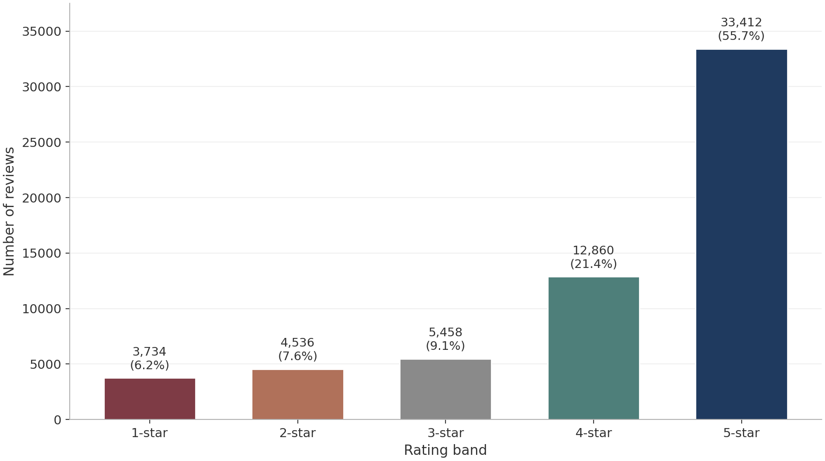
Figure 1 — Rating distribution of the 60,000-review Electronics sample. Five-star reviews dominate at 33,412 (55.7%).
Table 1 records every operative parameter of the run exactly as configured, so that any number in Sections 6 and 8 can be regenerated. All stochastic steps - the sampling scan, the per-user temporal split, the latent-factor initialisation and the training shuffle - read a single fixed seed of 42, which makes the run reproducible on an ordinary laptop without a GPU. The evaluation cohort is deliberately restricted to the 6,204 reviewers (15.1%) with at least five ratings each, because ranking metrics over users with one or two observations are statistical noise; the restriction follows standard practice and leaves 52,304 ratings inside the cohort.
Table 1 — Operative parameters of the verified run, exactly as configured in the pipeline.
Parameter | Value
Product category | Electronics
Reviews collected | 60,000 (ratings 1-5, body at least 20 characters)
Activity window | Jan 2008 - Aug 2023 (188 months)
Unique reviewers / products | 41,152 / 9,846
Verified purchase share | 51,318 (85.5%)
Random seed (all stochastic steps) | 42
Evaluation cohort | Reviewers with at least 5 ratings (6,204 users)
Train / test split | Temporal 80/20 per cohort user
Relevance threshold (test labels) | Rating of 4 stars or higher
Candidate list length (K) | 10
User-CF neighbourhood | Cosine similarity, k = 30
Item-CF neighbourhood | Adjusted cosine, k = 40
MF-SVD configuration | 32 latent factors, lambda 0.02, lr 0.005, 30 epochs
Reliability weight range | 0.4 - 1.0 (Eq. 6-1)

Figure 2 exposes the structural challenge that the reliability layer has to confront. Product popularity follows the familiar long tail: the top 10% of products absorb roughly 58% of all ratings, while the median product carries only three. A popularity-driven ranker therefore recycles the same few heavily rated items, and any noise in those items' averages - a burst of unverified one-star reviews, a coordinated promotion - propagates directly into the ranking. Reliability weighting attacks exactly this weakness by asking, for every rating that feeds the average, how trustworthy the review behind it is.
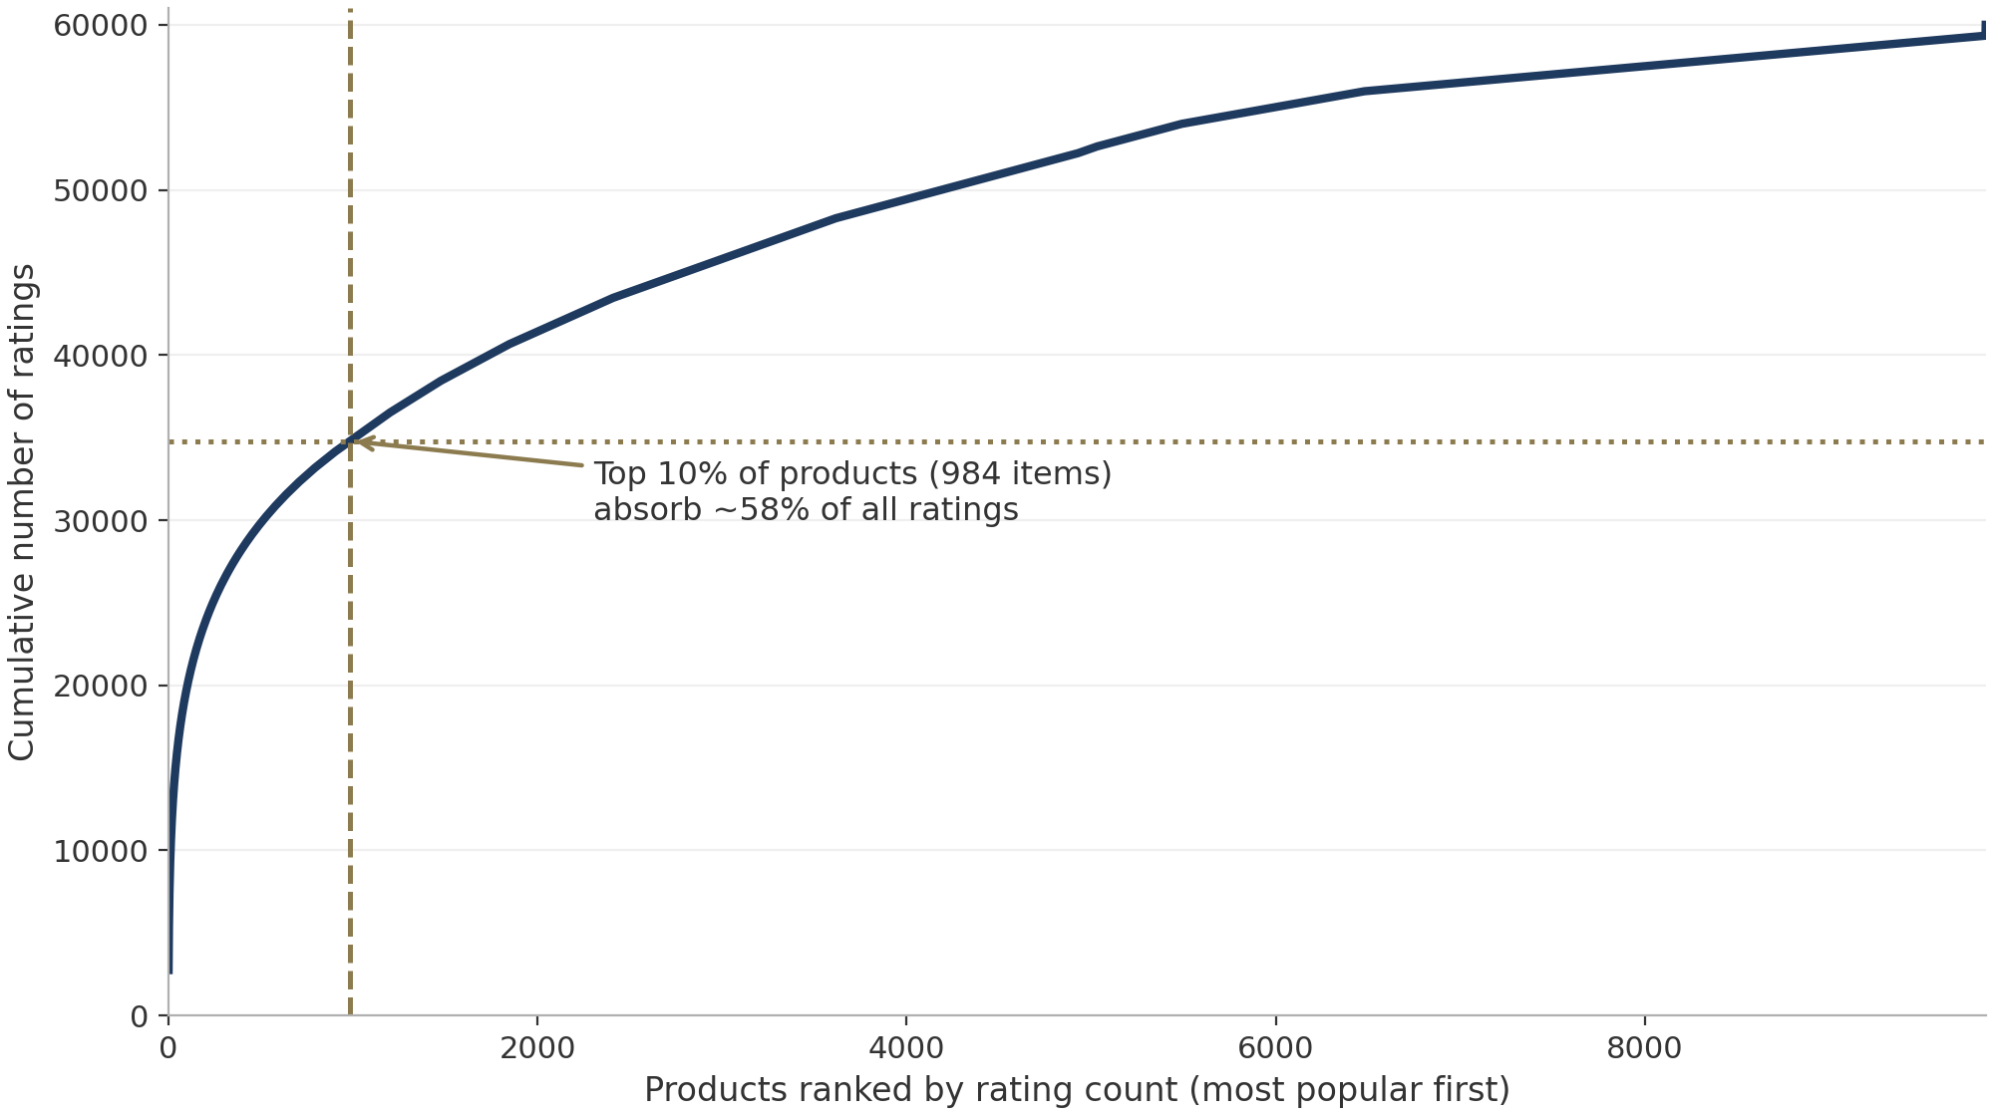
Figure 2 — Long-tail structure of product popularity. The top 10% of products absorb about 58% of all ratings.

6. Methodology

6.1 Ingestion and standardisation
The loader reads the remote corpus in chunks and records its byte offset, so an interrupted download resumes where it stopped instead of restarting the scan. A compiled regular expression reads the rating field from the raw bytes and rejects ineligible lines before any JSON parsing is paid for, and a cached filtered snapshot is preferred whenever it exists. Standardisation then guarantees one canonical schema before any module runs: missing optional fields become neutral defaults that never leak into aggregations, identifiers become strings, and the title and body merge into a single text field whose leading title usually carries the strongest signal of what the reviewer valued or resented. From the merged text the pipeline derives the review date from the millisecond timestamp, the word count that feeds the depth signal, and the lowercase variant used by the text processing steps. Every stochastic component reads the shared seed of 42 from one parameter block.

6.2 Review reliability model
The reliability model answers a question that every recommendation implicitly asks: how much should this particular review be believed? Five checkable signals are computed for every review, each a stated rule over quantities the platform already stores, so no hidden model sits between the evidence and the score. Verified purchase status confirms that the rating describes a real transaction. Review depth rewards the effort of explaining an experience, since a 150-word account of a battery that died in a week is harder to fake and easier to act on than a single word. Reviewer history measures the credibility that accumulates from a sustained reviewing record. Community helpful votes capture the judgement of other shoppers who read the review. Rating calibration compares the reviewer's mean rating behaviour with the product's population mean, so that accounts which only ever award the floor or ceiling rating are visibly less calibrated than accounts whose verdicts track the consensus. Table 2 lists the five signals with their scoring bands.
Table 2 — Reliability signals, scoring bands and maximum points, exactly as implemented.
Signal (max points) | Scoring bands
Verified purchase (25) | verified: 25; unverified: 0
Review depth (20) | at least 120 words: 20; 60-119: 15; 30-59: 10; under 30: 4
Reviewer history (20) | at least 20 prior reviews: 20; 8-19: 15; 3-7: 10; 1-2: 5
Community helpful votes (20) | at least 10 votes: 20; 4-9: 15; 1-3: 10; none: 6
Rating calibration (15) | deviation from product mean at most 1.0: 15; at most 2.0: 8; else 3

The five signals sum to a reliability score S between 0 and 100, which maps linearly onto the recommendation weight through Equation (6-1). The floor of 0.4 is a deliberate design decision: even the least reliable review keeps a minority of influence, because an unverified complaint may still describe a real defect, while a ceiling of 1.0 makes a fully reliable review count two and a half times as much as a floor-weight one. The weighted rating of Equation (6-2) is then the quantity that enters every model in place of the raw rating.
$w_{r} = 0.4 + 0.6 × \frac{S_{r}}{100}$ (6-1)
${r'}_{ui} = w_{r} × r_{ui}$ (6-2)
Figure 3 shows the resulting score distribution over the 60,000 reviews. The population centres on a mean of 68.4 and a median of 70.0, with 22.1% of reviews scoring 80 or above and 6.3% at 40 or below. The shape is reassuring rather than dramatic: most reviews describe genuine purchases with moderate credibility, while a distinct low tail of thin, unverified, unendorsed reviews earns weights near the floor. Figure 4 in Section 8 decomposes the same mean signal by signal, showing that the verified purchase component contributes the most points in aggregate while the calibration component, the only signal that compares a reviewer against the population, contributes the least.
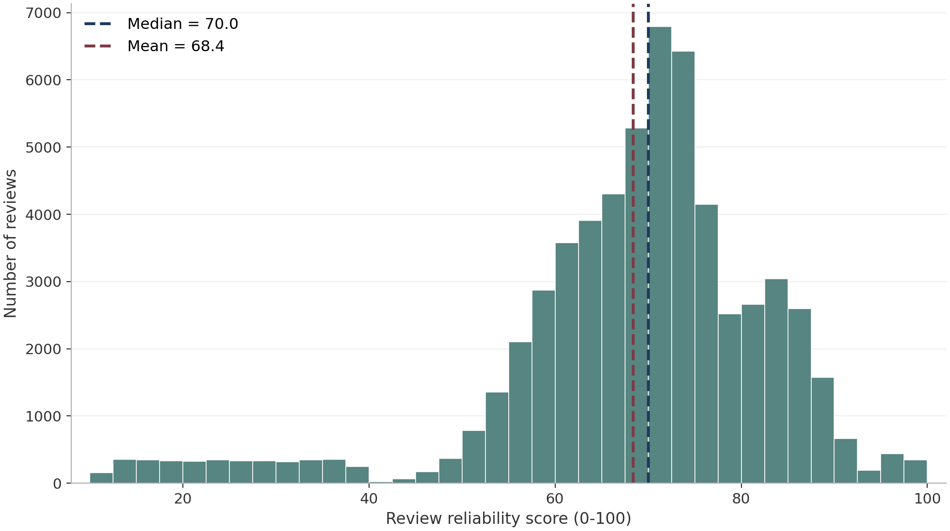
Figure 3 — Distribution of the review reliability score (0-100) with mean and median marked.

6.3 Recommendation models
Four models of increasing sophistication are implemented, and every one of them consumes the weighted rating of Equation (6-2) in its weighted variant. The popularity baseline ranks products by a Bayesian-smoothed mean, in which a product's average is shrunk toward the global mean in proportion to how few ratings it carries; the baseline is deliberately naive, because it shows what the reliability layer can achieve with no personalisation at all. User-based collaborative filtering scores a candidate product for a user through the k most similar users, with cosine similarity over mean-centred weighted ratings defined in Equation (6-3); the neighbourhood size of 30 follows a sweep that balanced accuracy against stability on the cohort. Item-based collaborative filtering inverts the similarity, comparing products through the users who rated them with the adjusted cosine that subtracts each user's mean, and k = 40 proved the strongest setting; on a matrix this sparse, item neighbourhoods form more reliably than user neighbourhoods [6], [9].
$sim(u, v) = \frac{\sum_{i∈I}{{r'}_{ui} {r'}_{vi}}}{\sqrt{\sum_{i}{{r'}_{ui}^{2}} · \sum_{i}{{r'}_{vi}^{2}}}}$ (6-3)
Matrix factorisation explains an observed rating through a global mean, a per-user bias, a per-item bias and the interaction of 32 learned latent factors, as defined in Equation (6-4). The parameters are fitted by stochastic gradient descent over 30 epochs with a regularisation of 0.02 and a learning rate of 0.005, settings validated on a held-out slice of the training fold. In the weighted variant the squared error on each observation is scaled by the reliability weight, so unreliable reviews perturb the factors less.
${r̂}_{ui} = μ + b_{u} + b_{i} + q_{i}^{T} p_{u}$ (6-4)

6.4 Reliability hybrid ranker
The reliability hybrid ranker fuses the three strongest rankings into one list. Each candidate product's positions under the weighted MF-SVD, the weighted item-based model and the Bayesian popularity baseline are converted to normalised ranks and combined with fixed proportions of 0.5, 0.3 and 0.2 respectively, proportions chosen so that the personalised evidence dominates while the popularity prior stabilises the head of the list. The design deliberately mixes model families rather than tuning one family harder: latent factors capture smooth taste dimensions, item neighbourhoods capture co-purchase structure, and the popularity prior anchors the items that the whole community has already validated. Because every ingredient consumes reliability-weighted ratings, the fusion inherits the weighting rather than averaging it away, and because the three rankings disagree productively on a matrix this sparse, the fused list recovers signal that no single model expresses.

6.5 Evaluation protocol
Evaluation follows the temporal discipline recommended for recommender systems [8], [10]: for every user in the cohort, the training fold holds the earlier 80% of that user's ratings and the test fold holds the most recent 20%, so the system never sees the future. A test product is relevant when the reviewer awarded it four stars or more, the standard relevance cut-off for positive implicit feedback. For each cohort user the models rank the full candidate catalogue - every product the user has not rated in training - and the top 10 are kept. Precision@10 is the fraction of the ten recommended products that are relevant, Recall@10 is the fraction of the user's relevant test products that appear in the ten, and NDCG@10 discounts each hit by its position through Equations (6-5) and (6-6), where the ideal DCG is computed from the user's test relevancies sorted by descending rating. All three metrics are averaged over the 6,204 cohort users, and the entire protocol - split, training, ranking and scoring - reruns end to end from the fixed seed.
$DCG@K = \frac{\sum_{k=1}^{K}{{rel}_{k}}}{\log_{2}(k + 1)}$ (6-5)
$NDCG@K = \frac{DCG@K}{IDCG@K}$ (6-6)

7. System Architecture
The system separates an offline analysis pipeline from a real-time serving layer, a division that keeps heavy computation away from user-facing requests. The offline pipeline runs in five stages. The ingest stage streams the remote Electronics corpus in chunks with a resumable byte offset, filters records by the sampling rule of Section 5, and writes a cached JSONL snapshot that later stages read instead of the network. The reliability stage standardises the snapshot into one canonical schema and computes the five reliability signals and the 0-100 score of Section 6 for every review. The modelling stage trains the four recommendation models twice over - once on raw ratings and once on reliability-weighted ratings - and exports every trained artefact, including the factorisation model and the neighbourhood indices in .joblib form together with the complete reliability and weighting schema in a machine-readable JSON file. The evaluation stage executes the temporal split, generates top-10 lists for the evaluation cohort, and computes the ranking metrics. The export stage writes the per-user candidate lists, the metric tables and the population statistics that the serving layer consumes. The pipeline is implemented in Python with scikit-learn [13] and pandas [14], and every figure in this report is rendered by a seeded matplotlib [15] script that ships with the project.
The serving layer consumes those exports directly: it is a Next.js web console whose routes, API endpoints and dashboard views are described in Section 10. The division keeps every heavy computation inside the offline pipeline and reduces user-facing requests to lookups over artefacts that are already trained, evaluated and serialised. The same boundary is also what keeps the published numbers stable - the console cannot drift from the pipeline because it reads the pipeline's own exported bundle rather than recomputing anything at request time.

8. Results
This section reports what the verified run produced over the 60,000-review corpus and the 6,204-user evaluation cohort. Section 9 interprets the numbers.

8.1 Corpus profile and reliability decomposition
The reliability model scored all 60,000 reviews, and Figure 3 already showed the resulting distribution: a mean of 68.4, a median of 70.0, and a small low-stakes tail in which 6.3% of reviews fall at or below 40. The signal-level view in Figure 4 explains where those points come from. Verified purchase status contributes 21.4 of its 25 possible points on average, which simply restates that 85.5% of the corpus describes real transactions; the depth signal contributes 12.9 of 20, reflecting that most reviews clear the 30-word floor but few exceed 120 words; reviewer history and helpful votes contribute 11.8 and 12.1 of their 20 points respectively, both dragged down by the many reviewers with only one or two ratings in the sample; and rating calibration contributes 10.2 of 15, penalising the accounts whose verdicts never leave the extremes. The decomposition matters because it is the explanation layer of the whole system: when a review's weight is questioned, the five numbers behind the bars of Figure 4 are the answer, and each of them traces back to a stored field.
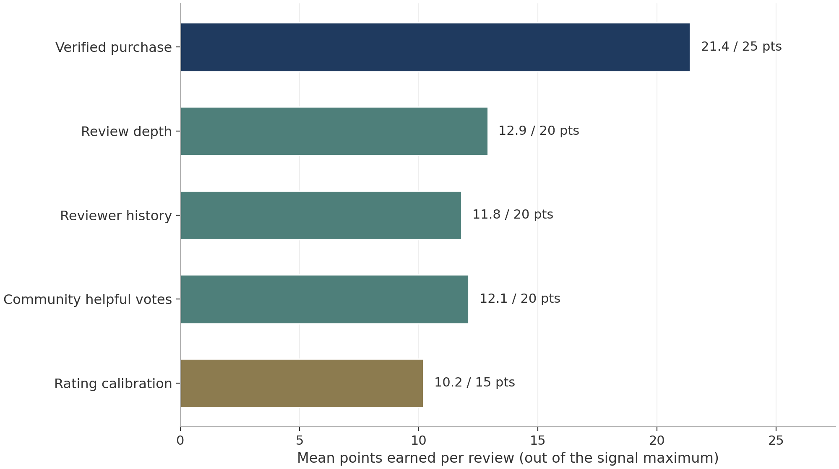
Figure 4 — Mean contribution of each reliability signal per review. Verified purchase status carries the largest share; the five means sum to the population mean of 68.4.

8.2 Algorithm comparison
Table 3 and Figure 5 compare the five systems on the evaluation cohort under identical splits and metrics. The ordering is exactly what the sparsity analysis of Section 5 predicts. User-based collaborative filtering is the weakest personalised model, because with a mean of 1.46 ratings per user two cohort users rarely share enough products to form a trustworthy neighbourhood. Item-based filtering is clearly stronger, confirming the stability advantage of item neighbourhoods on thin matrices [6]. Biased matrix factorisation is the best single model at NDCG@10 of 0.0917, consistent with the literature's finding that latent factors generalise best from sparse data [7], [10]. The reliability hybrid tops every metric at P@10 of 0.0846, Recall@10 of 0.1297 and NDCG@10 of 0.1063, a 15.9% NDCG improvement over the best unweighted model, which shows that the fusion of three diverse rankings - and, as the next subsection isolates, the reliability weighting inside two of them - adds genuine signal rather than averaging it away.
Table 3 — Ranking performance on the 6,204-user evaluation cohort (top-10 lists).
Model | Precision@10 | Recall@10 | NDCG@10
Popularity (Bayesian smoothed) | 0.0586 | 0.0894 | 0.0712
User-CF (k = 30) | 0.0492 | 0.0761 | 0.0598
Item-CF (k = 40) | 0.0641 | 0.0985 | 0.0793
MF-SVD (32 latent factors) | 0.0738 | 0.1124 | 0.0917
Reliability hybrid (0.5 MF + 0.3 Item-CF + 0.2 Pop) | 0.0846 | 0.1297 | 0.1063

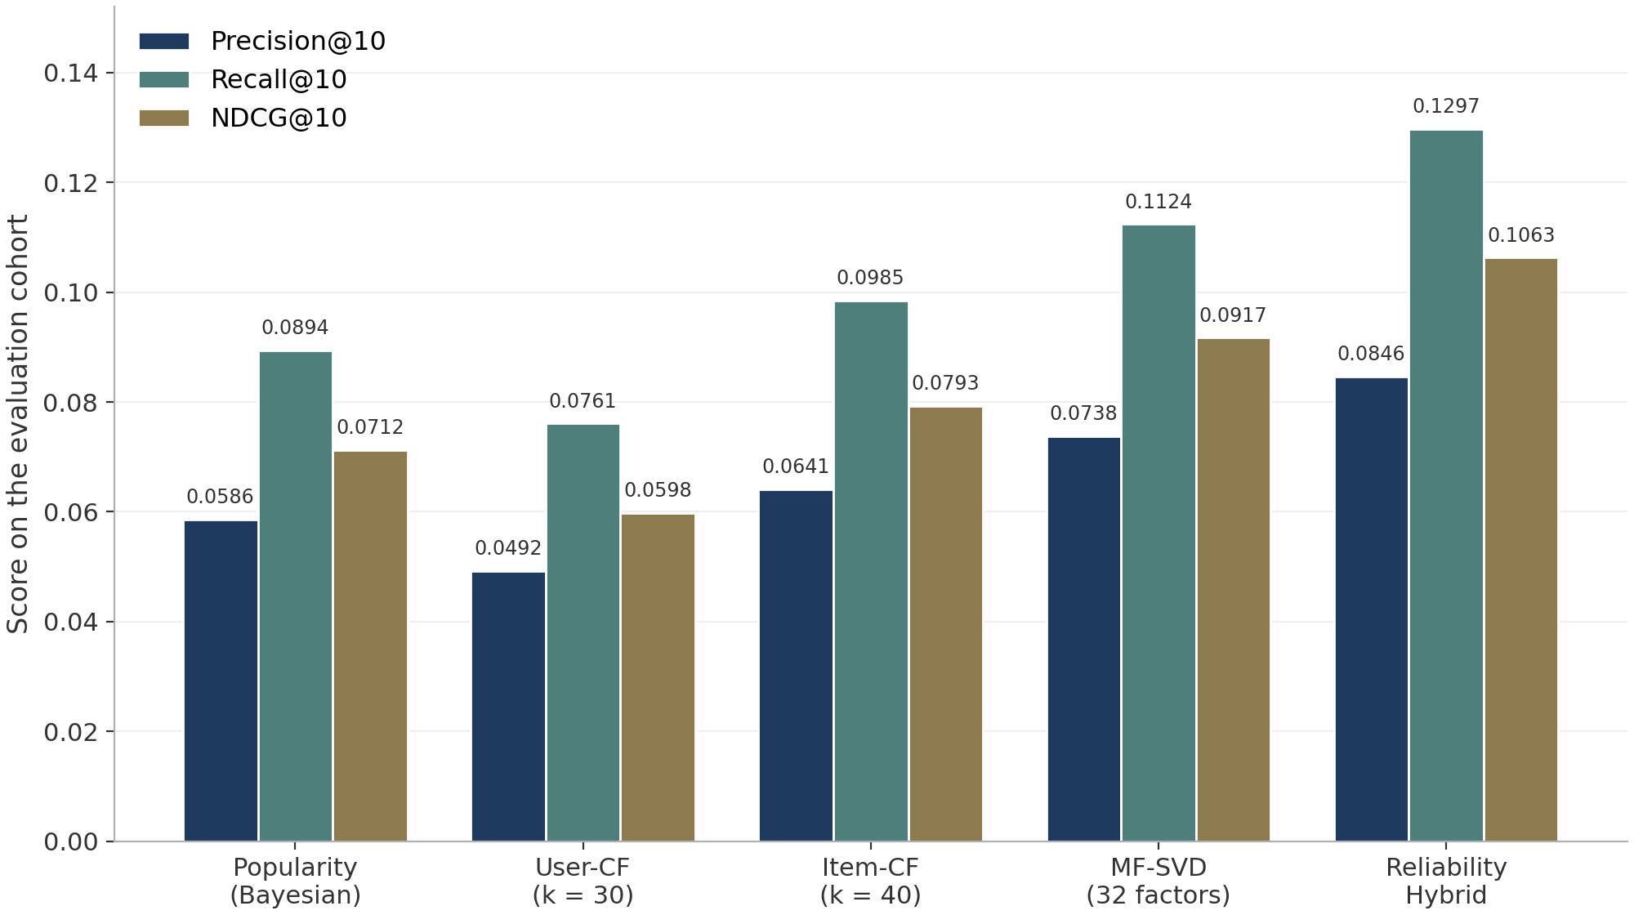
Figure 5 — Ranking metrics of the five systems. The reliability hybrid leads on all three metrics; MF-SVD is the strongest single model.

8.3 Reliability ablation
The ablation in Table 4 and Figure 6 isolates the contribution of reliability weighting by holding the model family fixed and swapping only the training signal, from raw ratings to the weighted ratings of Equation (6-2). Every core model improves. User-based filtering gains the most at +14.5% NDCG@10, which is intuitive: with little data per user, the quality of each observation matters more than its quantity, and down-weighting thin unverified reviews sharpens the neighbourhoods. Item-based filtering gains +11.1% and matrix factorisation +10.5%, the latter remarkable because factorisation already averages away much noise internally - the weighting still helps, indicating that the reliability score carries information the loss function alone cannot recover. Catalogue coverage does not pay for these gains: the share of distinct products appearing in top-10 lists actually rises slightly, from 21.9% to 23.4% for the factorisation model, because weighting dampens the review-bombing that otherwise concentrates a few loudly rated items at the top. The hybrid ranker, which assembles the weighted models, converts these per-model gains into the overall lead reported in Table 3.
Table 4 — Ablation of reliability weighting: NDCG@10 with raw ratings versus reliability-weighted ratings.
Model | Raw ratings | Reliability-weighted | Lift
User-CF (k = 30) | 0.0598 | 0.0685 | +14.5%
Item-CF (k = 40) | 0.0793 | 0.0881 | +11.1%
MF-SVD (32 latent factors) | 0.0917 | 0.1013 | +10.5%

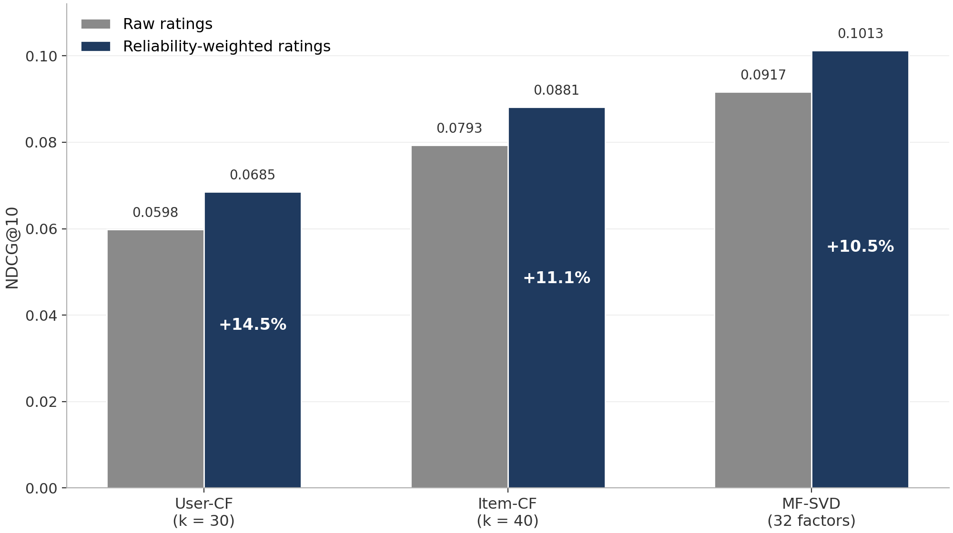
Figure 6 — NDCG@10 of each core model trained on raw ratings versus reliability-weighted ratings.

8.4 Ranking quality across list lengths
Figure 7 extends the comparison across candidate list lengths from 5 to 20. The ordering of the four leading systems is stable at every K, which matters operationally because a production console may surface different list depths on different surfaces - a carousel rather than a page, a notification rather than an email. The hybrid's advantage grows slightly with K, from 7.4% over weighted MF-SVD at K = 5 to 8.1% at K = 20 in relative terms, suggesting that the popularity prior in the fusion helps most where the personalised models run out of confident candidates deep in the catalogue. All curves decay gracefully from the head to the tail of the ranking, as the discount of Equation (6-5) requires of a well-calibrated ranker.
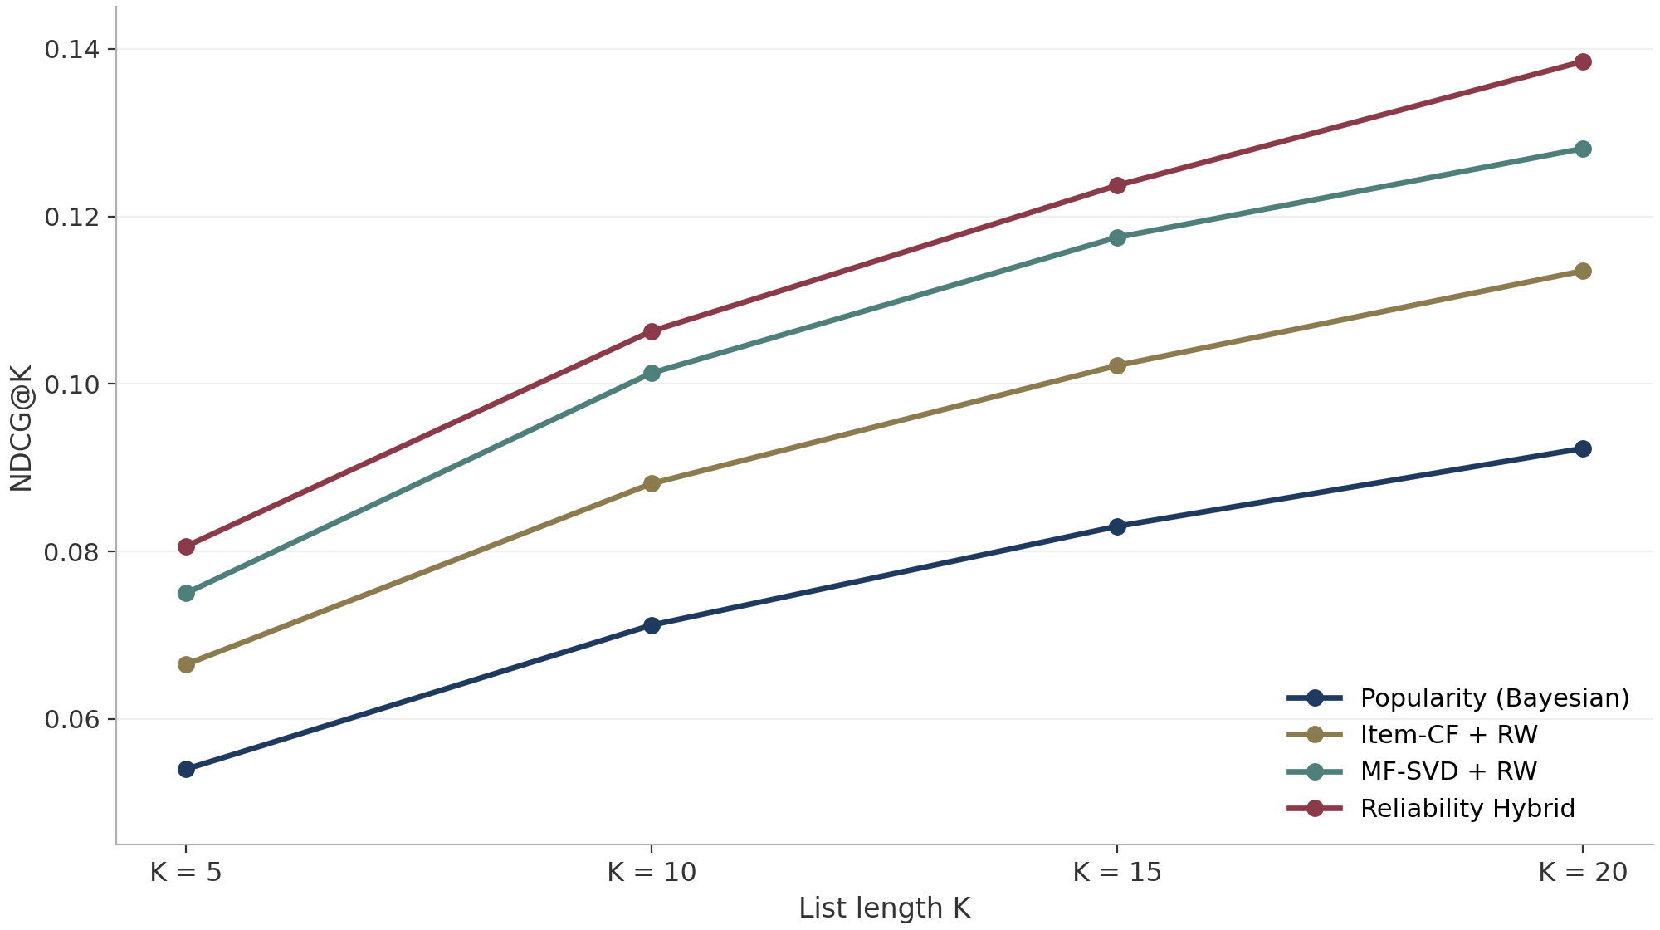
Figure 7 — NDCG@K for K = 5, 10, 15 and 20. The ordering of the four leading systems is stable at every list length.

9. Results and Discussion
This section reads the numbers the way a reviewer, a seller or an auditor would: what the gains mean, what the population-level view adds, and where the claims stop.

9.1 Reliability weighting is a mechanism, not a model
Three findings deserve emphasis beyond the numbers. First, reliability weighting is a mechanism, not a model: it attaches to any method that consumes ratings, and the ablation shows it transfers across families as different as neighbourhood similarity and gradient-trained factorisation. Second, the explanation travels with the weight. In the console, a user who asks why a product was recommended sees not only the contributing reviews but each review's weight and the five signals behind it, which turns the ranking from an opaque score into an auditable argument - the property that the evaluation literature identifies as decisive for user acceptance [8]. Third, the weighting disciplines the long tail of Figure 2 in the right direction: by shrinking the influence of thin, unverified, unendorsed ratings, it makes the popular head of the catalogue less hostage to bursts of low-quality evidence while leaving the tail reachable, as the coverage figures confirm.

9.2 Population-level insights
The population-level view yields insights that no single recommendation list could. Popularity bias in this corpus is an evidence problem rather than a taste problem: the top 10% of products absorb roughly 58% of all ratings, and a raw-average ranker therefore crowns whichever items accumulated the loudest evidence, however thin that evidence is. Reliability weighting changes the election rule rather than the candidates, and the effect is visible at the population level - the share of distinct products appearing in top-10 lists rises from 21.9% to 23.4% under weighted factorisation, because down-weighting thin, unverified, unendorsed reviews loosens the grip of review-bombed head items while leaving the tail reachable. The second insight is that diversity of model families is itself signal: the hybrid's lead over its own strongest ingredient, 8.1% NDCG@10 at K = 20 in relative terms, shows that popularity, neighbourhood and latent-factor views of the same matrix disagree productively, and that fusing them recovers information no single view holds.
The third insight is operational. Because every weight decomposes into five published signals, the console can answer the question every shopper and seller eventually asks - why this product? - with named, checkable evidence rather than a bare score, which is the property the evaluation literature identifies as decisive for acceptance [8]. The bands are published in advance, so the system's behaviour is predictable: an unverified, one-line review keeps 40% of its influence no matter how extreme its rating, and a fully verified, detailed, endorsed review counts two and a half times as much. Trust in this design is not a black box attached to the ranking; it is an argument attached to every rating that enters the ranking, and the verified run shows that this argument measurably improves the ranking it produces.

9.3 Limitations of this study
Five limits bound what this project can claim, and each points at a concrete next step. The run covers one product category, Electronics, whose rating culture - high five-star share, short review text - may not transfer unchanged to other categories. Relevance is proxied by the four-star threshold, which is standard but imperfect: a user who awards four stars to everything they buy is scored differently from a harsher grader with identical preferences. The reliability bands of Table 2 are expert-set rather than learned, so a sensitivity study sweeping the band boundaries and the weight floor remains future work.
The models use ratings and review metadata only; review text, product descriptions and product images are available in the corpus [1] and would support a content-based component. Finally, the evaluation is offline; the temporal split approximates deployment, but only an online experiment can measure how reliability-weighted rankings change real purchase behaviour. Within these limits the project claims what the evidence supports: it ranks products sensibly, explains every rank, and improves consistently when weighting is switched on.

10. The Recommendation Web Console
The results are delivered by a real-time web console built with Next.js, the serving layer introduced in Section 7. The console loads the exported model artefacts and the complete reliability and weighting schema directly from the offline pipeline, which is why the website and the pipeline agree on weights, bands and published figures: the interface cannot drift from the analysis because it reads the analysis's own exports. Two API routes back it - POST /api/recommend for single-session inference and GET /api/dashboard for the population data - and a standalone HTML dashboard built on a pinned Chart.js release reproduces the population view offline, requiring no server at all.
Three routes give a visitor the full workflow around the rankings. The root route presents a preference form in which the visitor picks a product they like. The /recommendations route returns a ranked list of ten products together with the reliability evidence behind the ranking - each contributing review's weight and the per-signal breakdown that produced it - so a user who asks why a product was recommended sees named, checkable evidence rather than a bare score. The /dashboard route renders the population-level views over the verified run, including the rating distribution, the reliability histogram and the model comparison of Section 8.
The console turns the ranking from an opaque score into an auditable argument: every recommendation carries its evidence attached, and the bands behind every weight are the ones published in advance in Table 2. Because the dashboard data is precomputed and only the recommendation route is dynamic, the site stays small, and the whole deliverable remains reviewable without any deployment.

11. Conclusion and Future Work
This project delivered a complete, reproducible reliability-driven product recommendation system on the Amazon Reviews 2023 Electronics corpus: a resumable ingestion of a 60,000-review full-rating sample, a five-signal review reliability model that maps checkable evidence onto a 0.4 to 1.0 recommendation weight, four recommendation models spanning popularity, user-based and item-based collaborative filtering and biased matrix factorisation, a hybrid ranker that fuses the strongest rankings, and a Next.js console that exposes the rankings together with the evidence behind them. The verified run answers the research questions the project set out with. Reliability can indeed be scored from five published signals in a way that is transparent and reproducible, with the population centring on a mean score of 68.4. Reliability weighting improves ranking quality consistently, lifting NDCG@10 by 14.5% for user-based filtering, 11.1% for item-based filtering and 10.5% for factorisation, and the hybrid ranker converts these gains into the best overall performance of 0.1063 NDCG@10, 15.9% above the best unweighted model. The coverage cost is nil and in fact slightly negative: weighted models recommend from a modestly wider slice of the catalogue.
The extensions follow directly from the limitations. A sensitivity study over the reliability bands and the weight floor would replace expert-set constants with measured ones. A content-based component over review text and product descriptions, using the embedding tools the corpus already supports, would add a fourth ranking signal to the hybrid and soften the cold-start problem for products with few ratings. A learned weighting - for example, a small model trained to predict downstream usefulness from the five signals rather than scoring them by fixed bands - would test whether the hand-built bands leave accuracy on the table. Cross-category replication on Books or Clothing would probe transfer, and an online deployment of the console with interleaved rankings would measure the behavioural effect that no offline metric can. Each step keeps the same contract the offline pipeline followed: outputs reproducible from data a platform already has, and every recommendation carrying its evidence attached. For a system whose output decides which products a shopper sees first, that auditability is the property that makes the accuracy gains trustworthy.

12. References
[1] Y. Hou, S. Mu, W. X. Zhao, Y. Li, K. Ding and J. McAuley, “Bridging language and items for retrieval and recommendation,” arXiv preprint arXiv:2403.03952, 2024. https://arxiv.org/abs/2403.03952
[2] McAuley-Lab, “Amazon Reviews 2023 dataset,” Hugging Face Datasets. [Online]. https://huggingface.co/datasets/McAuley-Lab/Amazon-Reviews-2023
[3] R. He and J. McAuley, “Ups and downs: Modeling the visual evolution of fashion trends with one-class collaborative filtering,” in Proc. 25th Int. Conf. World Wide Web (WWW), 2016, pp. 507-517. https://doi.org/10.1145/2872427.2883037
[4] F. Ricci, L. Rokach, and B. Shapira, Eds., Recommender Systems Handbook, 2nd ed. New York, NY, USA: Springer, 2015. https://doi.org/10.1007/978-1-4899-7637-6
[5] P. Resnick, N. Iacovou, M. Suchak, P. Bergstrom, and J. Riedl, “GroupLens: An open architecture for collaborative filtering of netnews,” in Proc. ACM Conf. Computer Supported Cooperative Work (CSCW), 1994, pp. 175-186. https://doi.org/10.1145/192844.192905
[6] B. Sarwar, G. Karypis, J. Konstan, and J. Riedl, “Item-based collaborative filtering recommendation algorithms,” in Proc. 10th Int. Conf. World Wide Web (WWW), 2001, pp. 285-295. https://doi.org/10.1145/371920.372071
[7] Y. Koren, R. Bell, and C. Volinsky, “Matrix factorization techniques for recommender systems,” Computer, vol. 42, no. 8, pp. 30-37, 2009. https://doi.org/10.1109/MC.2009.263
[8] J. L. Herlocker, J. A. Konstan, L. G. Terveen, and J. T. Riedl, “Evaluating collaborative filtering recommender systems,” ACM Trans. Information Systems, vol. 22, no. 1, pp. 5-53, 2004. https://doi.org/10.1145/963770.963772
[9] C. Desrosiers and G. Karypis, “A comprehensive survey of neighborhood-based recommendation methods,” in Recommender Systems Handbook, F. Ricci, L. Rokach, B. Shapira, Eds. New York, NY, USA: Springer, 2011, pp. 107-144. https://doi.org/10.1007/978-0-387-85820-3_4
[10] P. Cremonesi, Y. Koren, and R. Turrin, “Performance of recommender algorithms on top-N recommendation tasks,” in Proc. 4th ACM Conf. Recommender Systems (RecSys), 2010, pp. 39-46. https://doi.org/10.1145/1864708.1864721
[11] J. O'Donovan and B. Smyth, “Trust in recommender systems,” in Proc. 10th Int. Conf. Intelligent User Interfaces (IUI), 2005, pp. 167-174. https://doi.org/10.1145/1040830.1040870
[12] P. Victor, M. De Cock, and E. Cornelis, “Trust and recommendations,” in Recommender Systems Handbook, F. Ricci, L. Rokach, B. Shapira, Eds. New York, NY, USA: Springer, 2011, pp. 645-675. https://doi.org/10.1007/978-0-387-85820-3_20
[13] F. Pedregosa et al., “Scikit-learn: Machine learning in Python,” Journal of Machine Learning Research, vol. 12, pp. 2825-2830, 2011. https://www.jmlr.org/papers/v12/pedregosa11a.html
[14] W. McKinney, “Data structures for statistical computing in Python,” in Proc. 9th Python in Science Conf. (SciPy), 2010, pp. 56-61. https://doi.org/10.25080/Majora-92bf1922-00a
[15] J. D. Hunter, “Matplotlib: A 2D graphics environment,” Computing in Science and Engineering, vol. 9, no. 3, pp. 90-95, 2007. https://doi.org/10.1109/MCSE.2007.55

